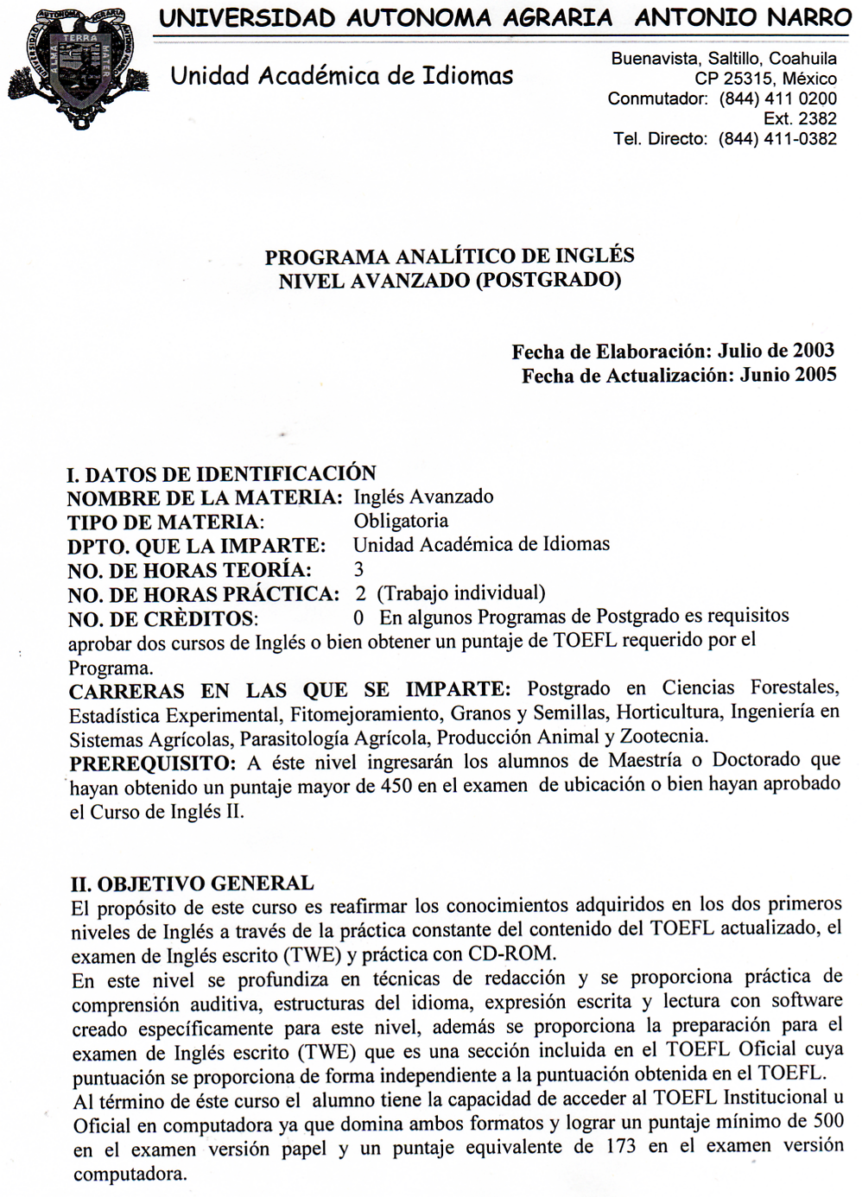

III. OBJETIVOS ESPECÍFICOS
- Practicar y aplicar las estrategias de cada sección del TOEFL incluyendo la práctica de redacción para el TWE
- Practicar mediante ejercicios escritos y en CD-ROM lo que permite el dominio de los dos formatos del TOEFL
- Practicar el examen TOEFL de forma completa para adquirir familiaridad con el mismo
- Mejorar el conocimiento general del idioma Inglés a través de refuerzo de las habilidades de comprensión auditiva, estructuras del idioma, expresión escrita, lectura y redacción

IV. TEMARIO
LISTENING COMPREHENSION SECTION
Is the first section of the TOEFL. In this section the students have the opportunity to demonstrate their ability to understand conversations and talks in English. Answers must be given on the basis of what is stated or implied by the speakers you hear.

The Listening Comprehension Section - Consists of fifty questions. You will listen to recorded materials and respond to question about the material.

I. THE LISTENING PART A QUESTIONS Tiempo: 10 horas

1. Strategies
- Skill 1: Focus on the second line
- Skill 2: Choose answers with synonyms
- Skill 3: Avoid similar sounds

2. Who, What, Where
- Skill 4: Draw conclusions about Who, What and Where
- Skill 5: Listen for Who and What in passives
- Skill 6: Listen for Who and What with multiple nouns

3. Negatives
- Skill 7: Listen for negative expressions
- Skill 8: Listen for double negative expressions
- Skill 9: Listen for "almost negative" expressions
- Skill 10: Listen for negatives with comparatives

4. Functions
- Skill 11: Listen for expressions of agreement
- Skill 12: Listen for expressions of uncertainty and suggestions
- Skill 13: Listen for emphatic expressions of surprise

5. Contrary Meanings
- Skill 14: Listen for wishes
- Skill 15: Listen for untrue conditions

6. Idiomatic Language
- Skill 16: Listen for two- and three- part verbs
- Skill 17: Listen for idioms

II. THE LISTENING PART B QUESTIONS Tiempo: 7 horas

1. Before Listening
- Skill 18: Anticipate the topics
- Skill 19: Anticipate the questions

2. While Listening
- Skill 20: Determine the topic
- Skill 21: Draw conclusions about Who, What Where and When
- Skill 22: Listen for answers in order

III. THE LISTENING PART C QUESTIONS Tiempo: 7 horas

1. Before Listening
- Skill 23: Anticipate the topics
- Skill 24: Anticipate the questions

2. While Listening
- Skill 25: Determine the topic
- Skill 26: Draw conclusions about Who, What, When Where
- Skill 27: Listen for answers in order

STRUCTURE AND WRITTEN EXPRESSION SECTION
This section is designed to measure the ability to recognize language that is appropriate for standard written English there are two kinds of questions in this section, with special directions for each type.

IV. THE STRUCTURE QUESTIONS Tiempo: 15 horas

1. Sentences with One Clause
- Skill 1: Be sure the sentence has a subject and a verb
- Skill 2: Be careful of objects of prepositions
- Skill 3: Be careful of appositives
- Skill 4: Be careful of present participles
- Skill 5: Be careful of past participles
2. Sentences with Multiple Clauses
- Skill 6: Use coordinate connectors correctly
- Skill 7: Use Adverb time and cause connectors correctly
- Skill 8: Use other adverb connectors correctly
3. More Sentences with Multiple Clauses
- Skill 9: Use noun clause connectors correctly
- Skill 10: Use noun clause connectors/subjects correctly
- Skill 11: Use adjective clause connectors correctly
- Skill 12: Use adjective clause connectors/subjects correctly
4. Sentences with Reduced Clauses
- Skill 13: Use reduced adjective clauses correctly
- Skill 14: Use reduced adverb clauses correctly
5. Sentences with Inverted Subjects and Verbs
- Skill 15: Invert the subjects and verbs with question words
- Skill 16: Invert the subject and verb with place expressions
- Skill 17: Invert the subject and verb with negatives
- Skill 18: Invert the subject and verb with conditionals
- Skill 19: Invert the subject and verb with comparisons

V. THE WRITTEN EXPRESSION QUESTIONS Tiempo: 20 horas

1. Problems with Subject/Verb Agreement
- Skill 20: Make verbs agree after prepositional phrases
- Skill 21: Make verbs agree after expressions of quantity
- Skill 22: Make inverted verbs agree
- Skill 23: Make verbs agree after certain words
2. Problems with Parallel Structure
- Skill 24: Use parallel structure with coordinate conjunctions
- Skill 25: Use parallel structure with paired conjunctions
- Skill 26: Use parallel structure with comparisons
3. Problems with Comparatives and Superlatives
- Skill 27: Form comparatives and superlatives correctly
- Skill 28: Use comparatives and superlatives correctly
- Skill 29: Use the irregular -er structure correctly
4. Problems with the Form of the Verb
- Skill 30: After have use the past participle
- Skill 31: After be use the present participle or the past participle
- Skill 32: After will, would, or other modals, use the base form of the verb
5. Problems with the Use of the Verb
- Skill 33: Know when to use the past with the present
- Skill 34: Use have and had correctly
- Skill 35: Use the correct tense with time expressions
- Skill 36: Use the correct tense with will and would
6. Problems with Passive Verbs
- Skill 37: Use the correct form of the passive
- Skill 38: Recognize active and passive meanings
7. Problems with Nouns
- Skill 39: Use the correct singular or plural noun
- Skill 40: Distinguish countable and uncountable nouns
- Skill 41: Recognize irregular plural of nouns
- Skill 42: Distinguish the person from the thing
8. Problems with Pronouns
- Skill 43: Distinguish subject and object pronouns
- Skill 44: Distinguish possessive adjectives and pronouns
- Skill 45: Check pronoun reference for agreement
9. Problems with Adjectives and Adverbs
- Skill 46: Use basic adjectives and adverbs correctly
- Skill 47: Use adjectives after linking verbs
- Skill 48: Position adjectives and adverbs correctly
10. More Problems with Adjectives
- Skill 49: Recognize -ly adjectives
- Skill 50: Use predicate adjective correctly
- Skill 51: Use -ed and -ing adjectives correctly
11. Problems with Articles
- Skill 52: Use articles with singular nouns
- Skill 53: Distinguish a and an
- Skill 54: Make articles agree with nouns
- Skill 55: Distinguish specific and general ideas
12. Problems with Prepositions
- Skill 56: Recognize incorrect prepositions
- Skill 57: Recognize when prepositions have been omitted
13. Problems with Usage
- Skill 58: Distinguish make and do
- Skill 59: Distinguish like, alike, and unlike
- Skill 60: Distinguish other, another, the others.

READING COMPREHENSION SECTION
This section is designed to measure the ability to read and understand short passages similar in topic and style to those that students are likely to encounter in North American universities and colleges.

The Reading Comprehension Section - Consists of five reading passages each followed by a number of reading comprehension and vocabulary questions. Topics are varied, but they are often information subjects that might be studies in an American university: American history, literature, art, architecture, geology, etc.

VI. READING COMPREHENSION Tiempo: 15 horas

1. Questions about the Ideas of the Passage
- Skill 1: Answer main idea questions correctly
- Skill 2: Recognize the organization of ideas
2. Directly Answered Questions
- Skill 3: Answer stated detail questions correctly
- Skill 4: Find "unstated" details
c. Skill 5: Find pronoun referents
3. Indirectly Answered Questions
- Skill 6: Answer implied detailed questions correctly
- Skill 7: Answer transition questions correctly
4. Vocabulary Questions
- Skill 8: Find definitions from structural clues
- Skill 9: Determine meanings from word parts
- Skill 10: Use context to determine meanings of difficult words
- Skill 11:Use contexts to determine meanings of simple words

5. Overall Review Questions
- Skill 12: Determine where specific information is found
- Skill 13: Determine the tone, purpose, or course

WRITTEN ENGLISH SECTION
This section provides the student with the opportunity to demonstrate their ability to write in English through essays
It is necessary to write an essay in 30 minutes, use specific reasons and details to support your ideas.

VII. WRITTEN ENGLISH Tiempo: 6 horas

1.Topic 1
- Do you agree or disagree with the following statement?
People should never live at home with their parents after the age of twenty-five.
2. Topic 2
- Do you agree or disagree with the following statement?
Children should be strongly pushed to achieve their maximum
3. Topic 3
- Do you agree or disagree with the following statement?
It is better to marry for practical reasons than for love

V. METODOLOGIA DE LA ENSEÑANZA
Los cursos de Inglés se basan en la enseñanza activa donde el alumno constituye el centro del proceso de enseñanza -aprendizaje. Durante el desarrollo del curso se trabajará en el desarrollo de las habilidades de comprensión auditiva, estructuras de la lengua, lectura y escritura con el propósito de adquirir las estrategias necesarias para presentar el TOEFL.
Para lo cual se trabajará con los métodos más modernos en la enseñanza de idiomas tales como:

Método de Aprendizaje Cooperativo. Prácticas en pares o grupos con la ventaja de maximizar la participación, los estudiantes son capaces de colaborar en respuestas, previa oportunidad de confirmar sus conocimientos y aprender de sus compañeros. La ansiedad se reduce y por lo tanto se incrementa el éxito en el aprendizaje.

Método Directo. La comprensión se basa en prácticas auditivas de idioma en grandes cantidades, los estudiantes escuchan el idioma a través del formato de preguntas y respuestas, la pronunciación correcta es relevante, se enfatiza en la descripción y narración.

Método de la Lectura. Este método se enfoca en la adquisición de vocabulario.

Método Audio-Lingual. Basado en diálogos con el objeto de desarrollar en el alumno la habilidad de los angloparlantes. El idioma es presentado de forma oral y no de forma escrita.
Método Natural. Se basa en el análisis lingüístico, el análisis textual, forma comunicativa del idioma y unidades gramaticales.

Método Situacional. El uso del idioma depende de un contexto cultural y situacional. Este método se centra en adquirir el lenguaje apropiado para diferentes ocasiones.

Método Funcional-Nocional. Se basa en las funciones del lenguaje, en la forma apropiada de usar el lenguaje con diferentes personas y la formalidad de las circunstancias.

VI. EVALUACIÓN
Se tomarán en cuenta los siguientes criterios para evaluar el logro de los objetivos planteados en este programa:

Examen de Diagnóstico, 3 Pre -Tests, 3 Post-Tests y Examen Final 70%
Tareas y trabajos escritos y de exposición 20%
Participación 10%

Es requisito cubrir el 85% de asistencia al curso para tener derecho a examen final y/o acreditar el curso. Al término del nivel avanzado, el alumno deberá obtener un puntaje mínimo de 500 para acreditar el curso.

VII. BIBLIOGRAFÍA BÁSICA
Philips, D. Preparation Course for the TOEFL Test Skills and Strategies Volume A
White Plains New York, 10606. Addison Wesley Longman, Second Edition. 1996

VIII. PROGRAMA ELABORADO POR:
M. Ed. Rosa Martha Arredondo Esquivel. Lic. Yanira Yaber Patiño.

IX. PROGRAMA ACTUALIZADO POR:
M. Ed. Rosa Martha Arredondo Esquivel. Lic. Yanira Yaber Patiño.

X. PROGRAMA APROBADO POR:

M. Ed. Rosa Martha Arredondo Esquivel.
Encargada de la Unidad Académica de Idiomas Junio de 2005

