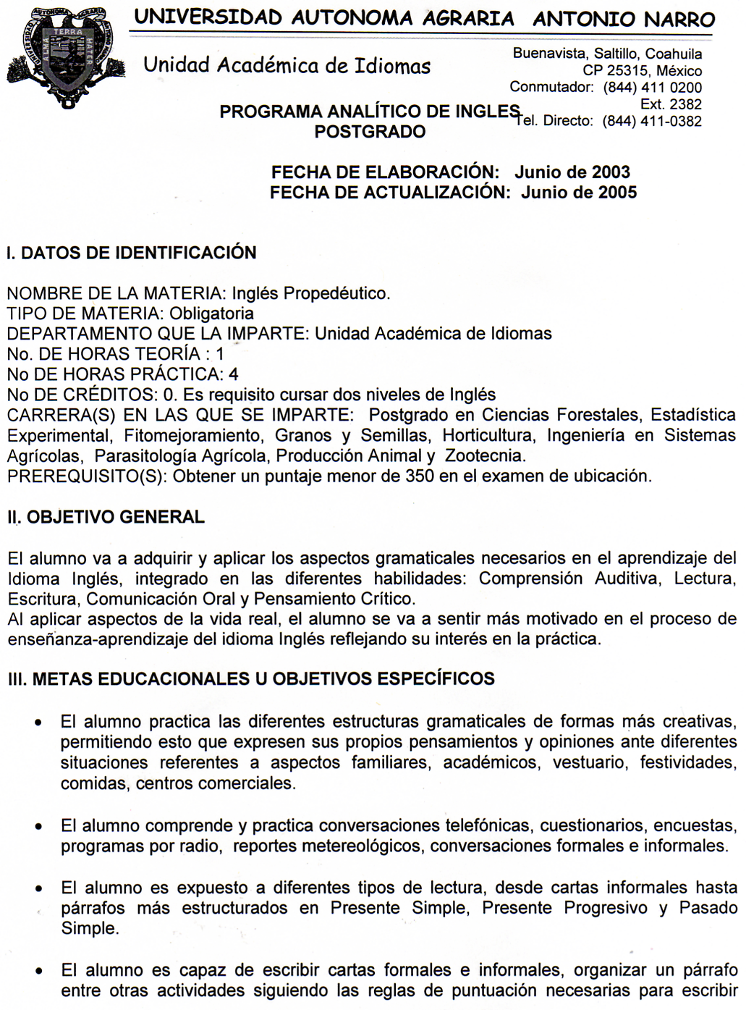
- correctamente, escribir notas de agradecimiento, describir personas, entrevistas, acerca de su propia rutina, y describe un lugar.
- El alumno expresa lo que piensa ante diferentes situaciones; transmitiendo sus opiniones a otra persona en grupos pequeños o bien al resto del grupo.

IV. TEMARIO

I. THE VERB BE: PRESENT AND PAST Tiempo: 10 hrs.
- The present affirmative
- The present negative
- Yes/No questions
- The past tense of Be

- NOUNS, ADJECTIVES AND PREPOSITIONS; THE PRESENT PROGRESSIVE
Tiempo: 12 hrs.
- Count Nouns A/An
a. Appendix 7: Spelling rules for plural nouns
- Descriptive Adjectives
- Prepositions of place
- Present Progressive
a. Appendix 13: Spelling rule for the present progressive

- WH – QUESTIONS; POSSESSIVES; PREPOSITIONS OF TIME Tiempo: 18 hrs.
- Questions with who, what and where
- Possessive nouns and possessive adjectives; Questions with whose
a. Appendix 8: Rules about possessive nouns
- Questions with when and what + noun, prepositions; Ordinal numbers
a. Appendix 3: List of cardinal and ordinal numbers, list of the days
- Questions with who, whom, and why; wh – questions and the present progressive
a. Appendix 4: Information about telling time
b. Appendix 6: Holidays in the United States

THE SIMPLE PRESENT TENSE Tiempo: 18 hrs.
- Simple Present Tense: Affirmative and Negative Statements
- Simple Present Tense: Yes/No Questions and Short Answers
- Simple Present Tense: Wh Questions
- Simple Present Tense and this/that/these/those
- Simple Present Tense and one/ones and it
a. Appendix 14: Spelling and pronunciation rules for the third person singular in the simple present tense

V. THE SIMPLE PAST TENSE Tiempo: 10 hrs.
- Simple Past Tense: Regular verbs – Affirmative and negative statements
- Simple Past Tense: Irregular verbs – Affirmative and negative statements
- Simple Past Tense: Yes/No and wh questions
a. Appendix 12: List of irregular past tense verbs
b. Appendix 15: Spelling and pronunciation rules for the simple past tense

VI. IMPERATIVES: SUGGESTIONS; THERE IS / THERE ARE Tiempo: 12 hrs.
- Imperatives; Suggestions with let’s, Why don’t you....?, Why don’t we ...?
- Subjects and Object Pronouns; Direct and Indirect Objects
- There is / There are, Is there ...? / Are there ...?
- Numbers, Quantifiers and Questions with How many…..?
a. Appendix 5: Parts of the Body; Medical Problems

V. METODOLOGIA DE ENSEÑANZA-APRENDIZAJE

- Método Directo
- Método Natural
- Método de Aprendizaje Cooperativo
- Método de Respuesta Física Total (TPR)
- Método de Lectura
- Método Audio-Lingual
- Método Suggestopedia

VI. EVALUACIÓN

Se tomarán en cuenta los siguientes criterios para evaluar el logro de los objetivos planteados en el programa.

Exámenes parciales (7): 70%
Tareas: 20%
Participación: 10%

Existe la posibilidad de Exentar obteniendo 90%.
Es requisito cubrir el 85% de la asistencia para poder acreditar el curso, exentar, o tener derecho a examen final.

VII. BIBLIOGRAFÍA BÁSICA

Gordon Deborah, “Focus on Grammar” Basic Level.
White Plains, NY 10606.Pearson Education Second Edition 2000

VIII. BIBLIOGRAFÍA COMPLEMENTARIA

Eckstut Samuela, “Focus on Grammar” Basic Level. Workbook
White Plains, NY 10606.
Pearson Education. Second Edition 2000

IX. PROGRAMA ELABORADO POR:

M.Ed. Rosa Martha Arredondo Esquivel Lic. Yanira Yaber Patiño

X. PROGRAMA APROBADO POR:

M.Ed. Rosa Martha Arredondo Esquivel Junio de 2005

